PHP Getting the time and date

PHP is able to access the system date, which is a useful ability. Dates and times can be used for a variety of tasks, from simply displaying the correct time on the page to creating a time stamp of when a record was created.

To get a simple date use the date() function.

* d – Represents the day (01 to 31)
* jS- the day with superscript.
* m- Represents the month (01 to 12)
* F-Month (in words)
* Y – represents a year (in 4 digits)
* l- (lower case L) – represents the day of the week. (in words)

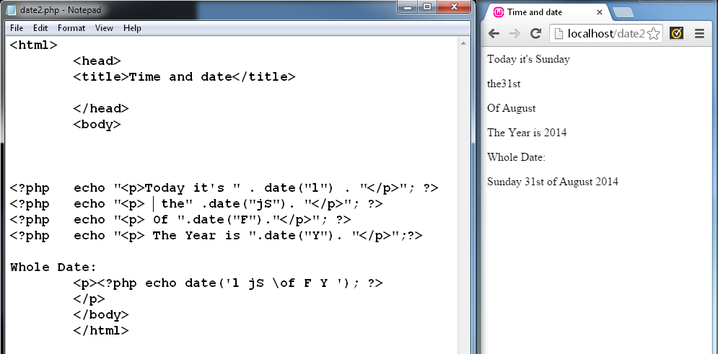

# Get a Simple Time.

* h - 12-hour format of an hour with leading zeros (01 to 12)
* i - Minutes with leading zeros (00 to 59)
* s - Seconds with leading zeros (00 to 59)
* a - Lowercase Ante meridiem and Post meridiem (am or pm)

*the PHP date() function will return the current date/time of the server.*

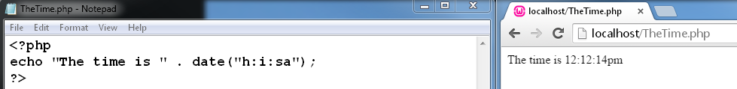

## PHP 5 Date/Time Functions

|  |  |
| --- | --- |
| **Function** | **Description** |
| [checkdate()](http://www.w3schools.com/php/func_date_checkdate.asp) | Validates a Gregorian date |
| [date_add()](http://www.w3schools.com/php/func_date_date_add.asp) | Adds days, months, years, hours, minutes, and seconds to a date |
| [date_create_from_format()](http://www.w3schools.com/php/func_date_create_from_format.asp) | Returns a new DateTime object formatted according to a specified format |
| [date_create()](http://www.w3schools.com/php/func_date_date_create.asp) | Returns a new DateTime object |
| [date_date_set()](http://www.w3schools.com/php/func_date_date_set.asp) | Sets a new date |
| [date_default_timezone_get()](http://www.w3schools.com/php/func_date_default_timezone_get.asp) | Returns the default timezone used by all date/time functions |
| [date_default_timezone_set()](http://www.w3schools.com/php/func_date_default_timezone_set.asp) | Sets the default timezone used by all date/time functions |
| [date_diff()](http://www.w3schools.com/php/func_date_date_diff.asp) | Returns the difference between two dates |
| [date_format()](http://www.w3schools.com/php/func_date_date_format.asp) | Returns a date formatted according to a specified format |
| [date_get_last_errors()](http://www.w3schools.com/php/func_date_get_last_errors.asp) | Returns the warnings/errors found in a date string |
| date_interval_create_from_date_string() | Sets up a DateInterval from the relative parts of the string |
| [date_interval_format()](http://www.w3schools.com/php/func_date_interval_format.asp) | Formats the interval |
| [date_isodate_set()](http://www.w3schools.com/php/func_date_isodate_set.asp) | Sets the ISO date |
| [date_modify()](http://www.w3schools.com/php/func_date_modify.asp) | Modifies the timestamp |
| [date_offset_get()](http://www.w3schools.com/php/func_date_offset_get.asp) | Returns the timezone offset |
| [date_parse_from_format()](http://www.w3schools.com/php/func_date_parse_from_format.asp) | Returns an associative array with detailed info about a specified date, according to a specified format |
| [date_parse()](http://www.w3schools.com/php/func_date_date_parse.asp) | Returns an associative array with detailed info about a specified date |
| [date_sub()](http://www.w3schools.com/php/func_date_date_sub.asp) | Subtracts days, months, years, hours, minutes, and seconds from a date |
| [date_sun_info()](http://www.w3schools.com/php/func_date_sun_info.asp) | Returns an array containing info about sunset/sunrise and twilight begin/end, for a specified day and location |
| [date_sunrise()](http://www.w3schools.com/php/func_date_sunrise.asp) | Returns the sunrise time for a specified day and location |
| [date_sunset()](http://www.w3schools.com/php/func_date_sunset.asp) | Returns the sunset time for a specified day and location |
| [date_time_set()](http://www.w3schools.com/php/func_date_time_set.asp) | Sets the time |
| [date_timestamp_get()](http://www.w3schools.com/php/func_date_timestamp_get.asp) | Returns the Unix timestamp |
| [date_timestamp_set()](http://www.w3schools.com/php/func_date_timestamp_set.asp) | Sets the date and time based on a Unix timestamp |
| [date_timezone_get()](http://www.w3schools.com/php/func_date_timezone_get.asp) | Returns the time zone of the given DateTime object |
| [date_timezone_set()](http://www.w3schools.com/php/func_date_timezone_set.asp) | Sets the time zone for the DateTime object |
| [date()](http://www.w3schools.com/php/func_date_date.asp) | Formats a local date and time |
| [getdate()](http://www.w3schools.com/php/func_date_getdate.asp) | Returns date/time information of a timestamp or the current local date/time |
| [gettimeofday()](http://www.w3schools.com/php/func_date_gettimeofday.asp) | Returns the current time |
| [gmdate()](http://www.w3schools.com/php/func_date_gmdate.asp) | Formats a GMT/UTC date and time |
| [gmmktime()](http://www.w3schools.com/php/func_date_gmmktime.asp) | Returns the Unix timestamp for a GMT date |
| [gmstrftime()](http://www.w3schools.com/php/func_date_gmstrftime.asp) | Formats a GMT/UTC date and time according to locale settings |
| [idate()](http://www.w3schools.com/php/func_date_idate.asp) | Formats a local time/date as integer |
| [localtime()](http://www.w3schools.com/php/func_date_localtime.asp) | Returns the local time |
| [microtime()](http://www.w3schools.com/php/func_date_microtime.asp) | Returns the current Unix timestamp with microseconds |
| [mktime()](http://www.w3schools.com/php/func_date_mktime.asp) | Returns the Unix timestamp for a date |
| [strftime()](http://www.w3schools.com/php/func_date_strftime.asp) | Formats a local time and/or date according to locale settings |
| [strptime()](http://www.w3schools.com/php/func_date_strptime.asp) | Parses a time/date generated with strftime() |
| [strtotime()](http://www.w3schools.com/php/func_date_strtotime.asp) | Parses an English textual datetime into a Unix timestamp |
| [time()](http://www.w3schools.com/php/func_date_time.asp) | Returns the current time as a Unix timestamp |
| [timezone_abbreviations_list()](http://www.w3schools.com/php/func_date_timezone_abbreviations_list.asp) | Returns an associative array containing dst, offset, and the timezone name |
| [timezone_identifiers_list()](http://www.w3schools.com/php/func_date_timezone_identifiers_list.asp) | Returns an indexed array with all timezone identifiers |
| [timezone_location_get()](http://www.w3schools.com/php/func_date_timezone_location_get.asp) | Returns location information for a specified timezone |
| [timezone_name_from_ abbr()](http://www.w3schools.com/php/func_date_timezone_name_from_abbr.asp) | Returns the timezone name from abbreviation |
| [timezone_name_get()](http://www.w3schools.com/php/func_date_timezone_name_get.asp) | Returns the name of the timezone |
| [timezone_offset_get()](http://www.w3schools.com/php/func_date_timezone_offset_get.asp) | Returns the timezone offset from GMT |
| [timezone_open()](http://www.w3schools.com/php/func_date_timezone_open.asp) | Creates new DateTimeZone object |
| timezone_transitions_get() | Returns all transitions for the timezone |
| [timezone_version_get()](http://www.w3schools.com/php/func_date_timezone_version_get.asp) | Returns the version of the timezone |

**Exercise: Display the time and the Date in long format.**

<!-- Christopher van Herwynen --->

<html>

<?php

date_default_timezone_set("GMT+11");

echo date('l jS \of F Y h:i:s A');

?>

</html>